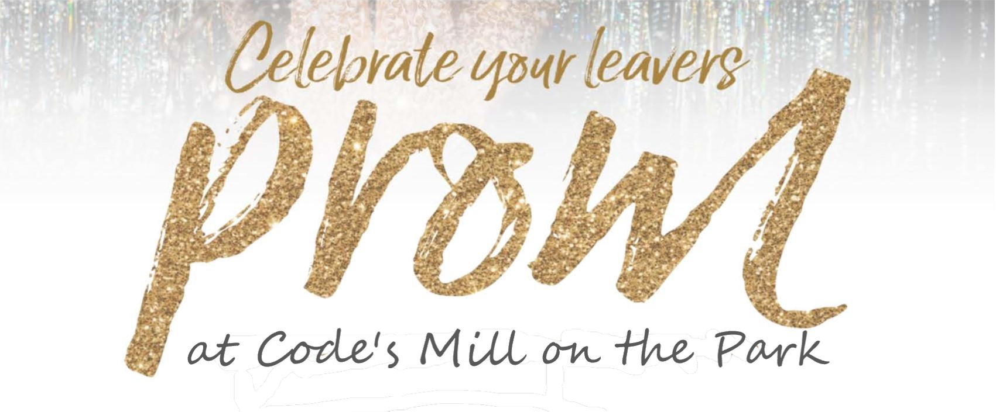
Let us enchant you in our Carding Ballroom. Each table is set for eight, dressed with
Ivory linens, ivory chair covers, glistening tableware and a classic centrepiece.
Coloured napkin to match your school colour or prom theme add a special touch.
Step into our photo booth and create memories that will last a life time!
Enjoy pre-dinner mocktail upon arrival, a multi-course dinner, and a great DJ to dance the night away.

Plated Dinner Service

Starter (1)

Caesar Salad with bacon, Croutons, and a Creamy Garlic Parmesan Dressing

Mixed Field Greens with house vinaigrette

Main (1)

Spinach and Ricotta Stuffed Chicken Breast, vegetable medley & herb roasted potatoes

Grilled Beef Tenderloin (6oz) with brandy peppercorn sauce, green bean bouquet & herb roasted potatoes

Baked Spinach Cannelloni with herbed goat cheese & balsamic reduction
Dessert (1)

NY Style Cheesecake with maple blackberry coulis

Apple Blossom with caramel sauce

Maple Bourbon Pecan Tart with Cranberry Caramel & Whipped Cream

Set Menu - All guest to have the same apart from any Dietary Requirements or
Vegetarians which can be catered for on a separate basis

$60.00 per ticket or $100.00 per couple

Added Extras
Pre order Pitchers of Mocktail for the table ($10.00 per pitcher), add tea and coffee at $2.95 per person.
Sweet Shop to include an assortment of sweets, jars scoops, bags etc. serving 100 at $250.00.

Terms & Conditions Apply – Please ask the Event Team for Booking Terms & Conditions
Minimum Numbers will apply to all packages & will be quoted for upon booking.
Contact Michelle@codesmill.com

